What is DVWA
DVWA stands for Damn Vulnerable Web Application
It is a demo web application used by Ethical Hackers to demonstrate how vulnerabilities inside a web application(website) can be exploited.
DVWA is a PHP application which can be executed using XAMPP Server.
Step 1 :DVWA can be downloaded from https://github.com/digininja/DVWA/archive/refs/heads/master.zip
Step 2: XAMPP can be downloaded from https://sourceforge.net/projects/xampp/files/XAMPP%20Windows/8.2.12/xampp-windows-x64-8.2.12-0-VS16-installer.exe
Download the above 2 applications.
Install XAMPP, the installation is really simple > just a matter of clicks and installation is done.
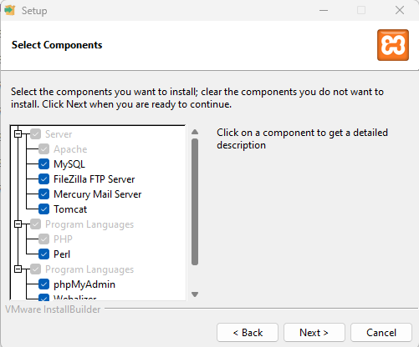
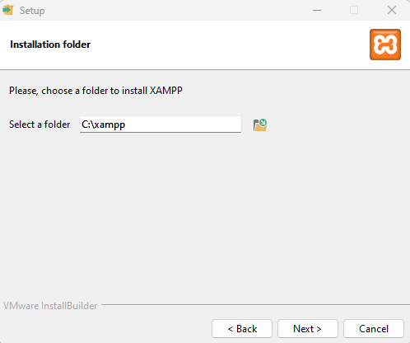
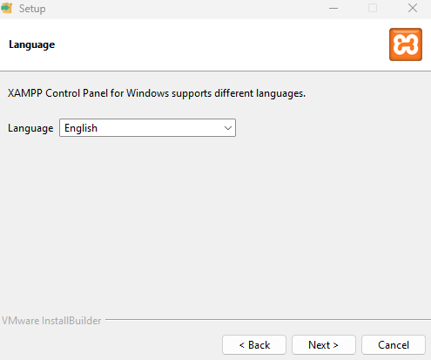
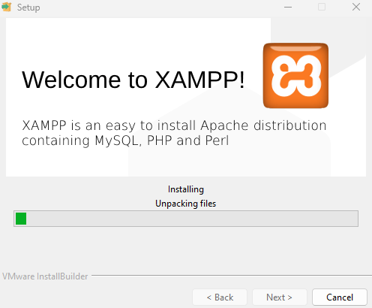
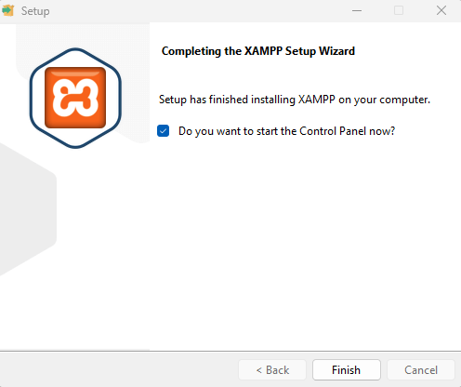
Step 3: Open the control panel
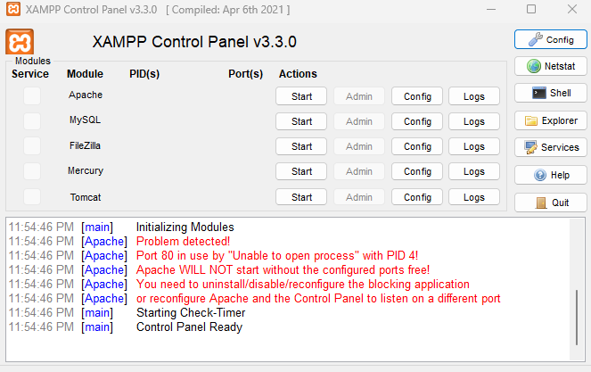
Step 4: Click on Start Apache & MySQL, usually the Apache Starts on the default 80 Port but if incase
If in case the Apache fails to start on the default port, you need to update the apache httpd config file with the below Listen 80 to Listen 8080 ( search for Listen 80 one the file is open in notepad & replace 80 with 8080)

Step 5: To edit the httpd config, click on Config button, select Apache (httpd.conf) to open the Apache https config file.
Step 6: Once the configuration is done Start the Apache & MySQL again
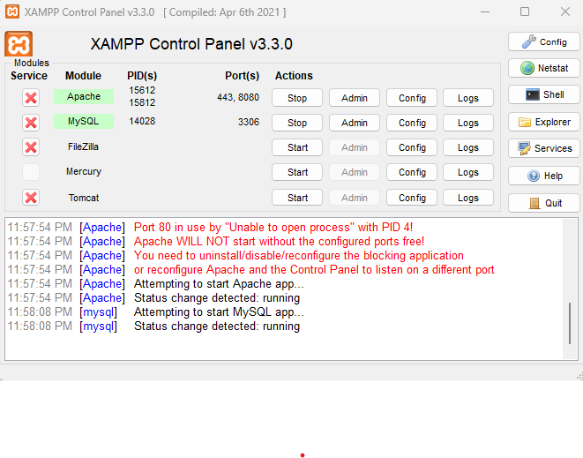
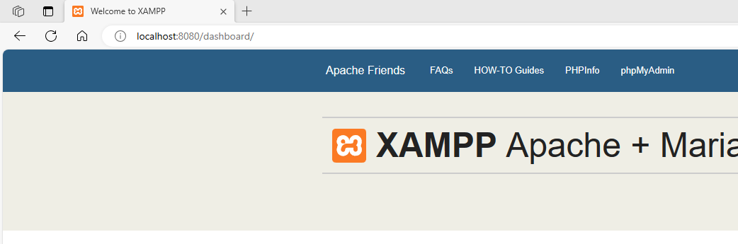
Step 7: Click on Shell on the XAMPP Control Panel and execute the below commands.
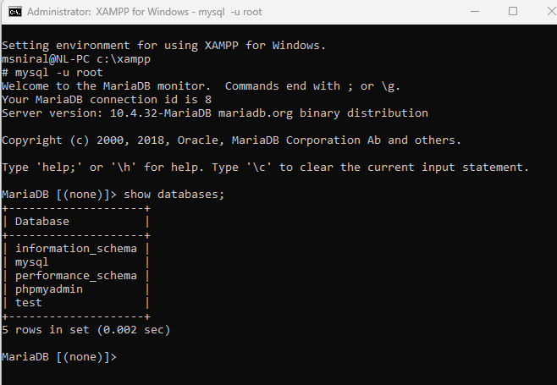
Step 8 : Copy the DVWA-master folder to C:\xampp\htdocs\
Step 9: After copying, rename the file “config.inc.php.dist” to “config.inc.php” which will be present in the below path
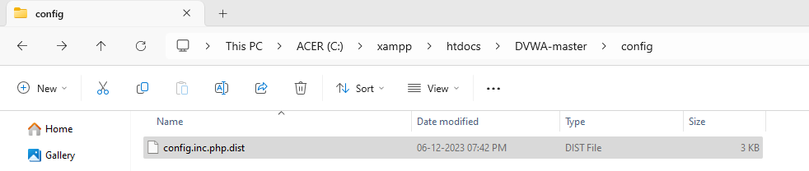

Step 10: Open the file and change the values of db_user to root & db_password to null
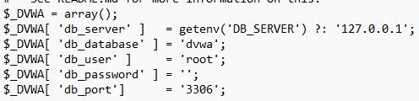
Step 11 : Go to the below url ( 8080 as in this case the apache is running on 80 port)
http://localhost:8080/dvwa-master/setup.php
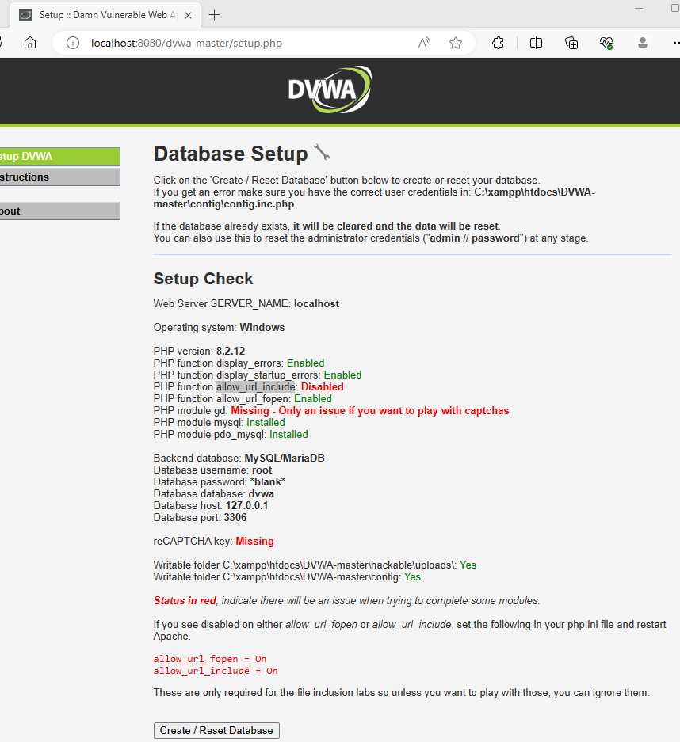

Step 12: Click on Create/Reset the database, once the database is created, it will take you to the login page automatically.
If not, you can go to the url http://localhost:8080/dvwa-master/login.php
Usernmae: admin
Password: password
Step 13: Once logged in the security level which is configured will be impossible, change the same to Low.
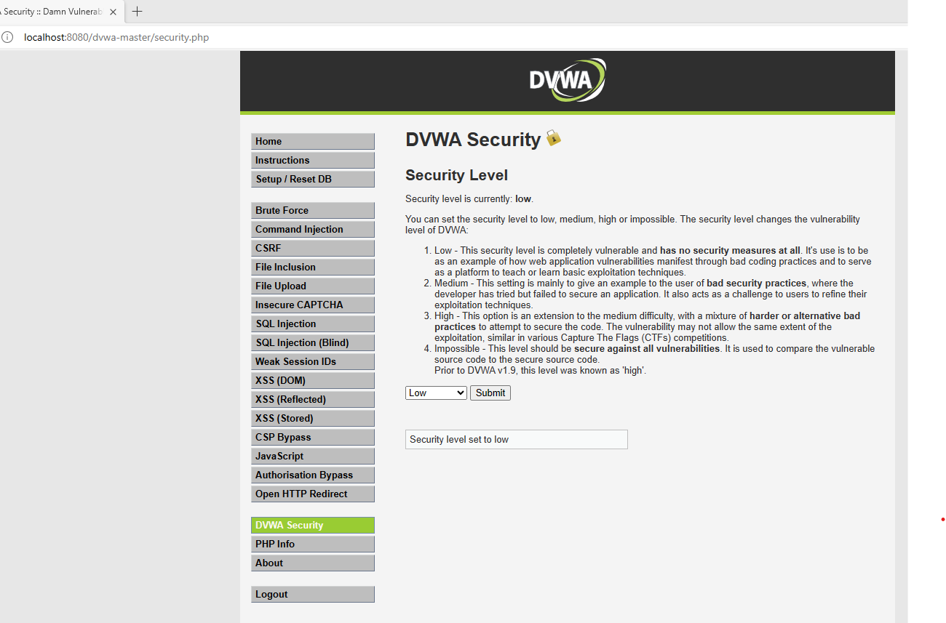
Step 14: Open : C:\xampp\php\php.ini file , search for allow_url_include, change the value to On from Off & save & close the file & stop and start the apache from xampp control panel.
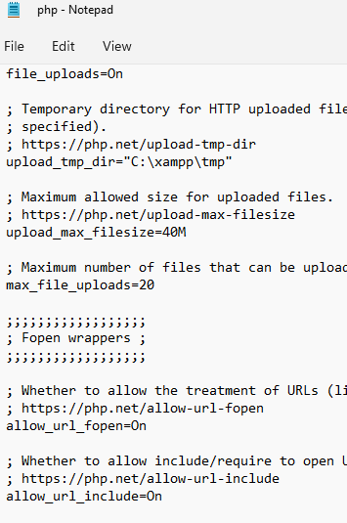

Lab to Perform the File Inclusion.
What is File Inclusion?
A process of accessing a file which is not a part of the hosted web application using the directory traversing method.
Say for example under the DVWA application, there is an directory – or – folder named etc which is present under c:\ i.e. C:\etc
That folder is containing the sensitive information of usernames and passwords
A hacker can exploit the file inclusion vulnerability by guessing the directory name and the file name.
Steps 15 :
Open the DVWA site (assuming you have already log into the DVWA App)
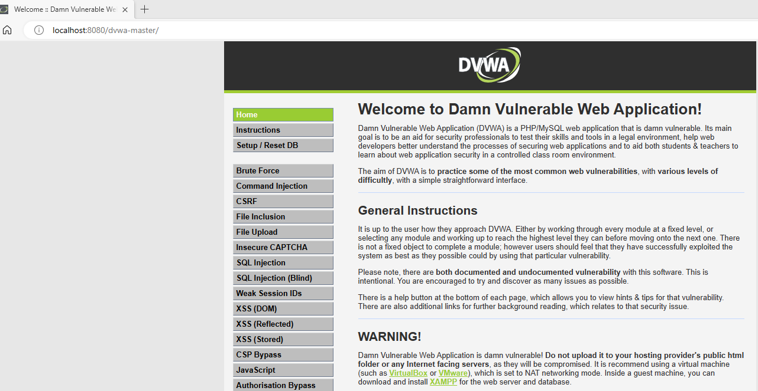
Step 16: On the computer where the DVWA is hosted, go to C drive and create a folder with name etc and create few text file or html files or both.
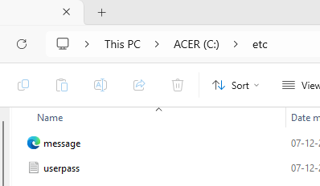

Step 17: On the DVWA app, click on Fileinclusion & click on any of the sample file and see how the URL changes.
For example:
http://localhost:8080/dvwa-master/vulnerabilities/fi/?page=include.php
if I click on file2.php, the URL will be as below
http://localhost:8080/dvwa-master/vulnerabilities/fi/?page=file2.php
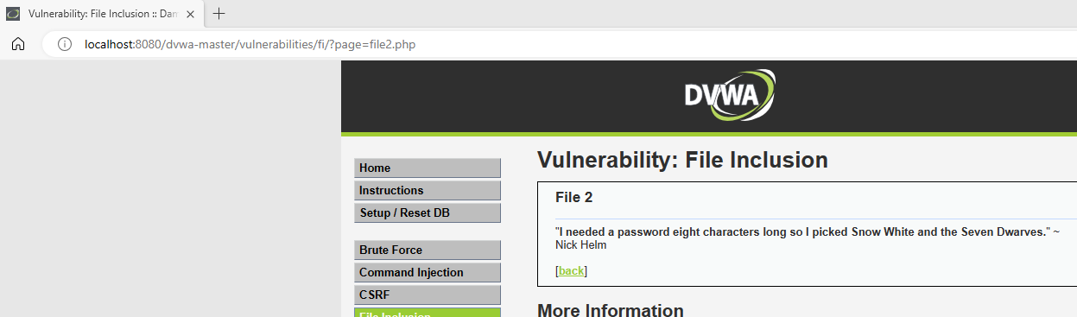
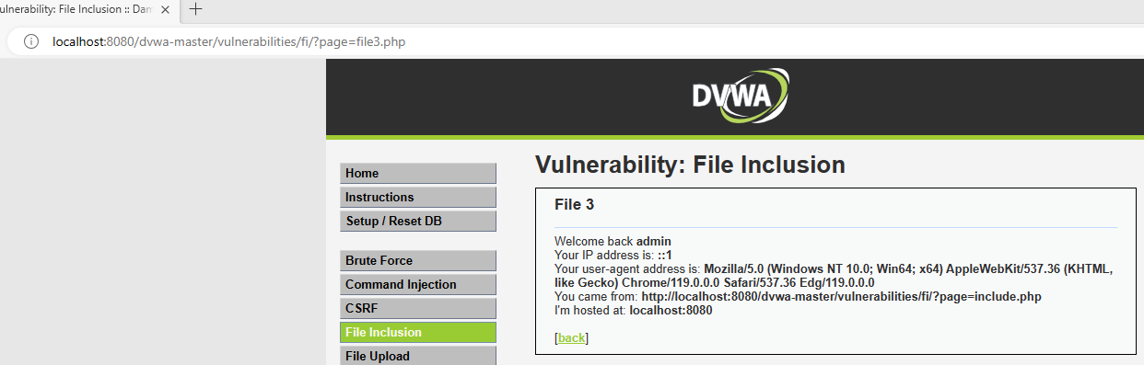
Step 18 : Now the hacker wants to access the etc folder which is present in the c drive.
So usually by guessing the directory path he may get the access to that particular folder.
The hacker tries another attempt to check if the applied method of guessing the file name is working correctly or not, so the hacker tries to change the file2.php to file4.php and tries the luck.
http://localhost:8080/dvwa-master/vulnerabilities/fi/?page=file4.php
Now to get to the root directory i.e. in C drive where the etc folder is present the hacker tries to traverse the folder path in the URL parameter.
Consider the hacker wants to access the file c:\etc\password.txt
Taking the reference from the below url the hacker can guess the C drive can be 5 folders behind where the application is hosted.
http://localhost/dvwa-master/vulnerabilities/fi/?page=file2.php
On changing the URL like below
http://localhost:8080/dvwa-master/vulnerabilities/fi/?page=../../../../../etc/userpass.txt
The hacker got access to the file even when the files were not the part of the WebApplication.
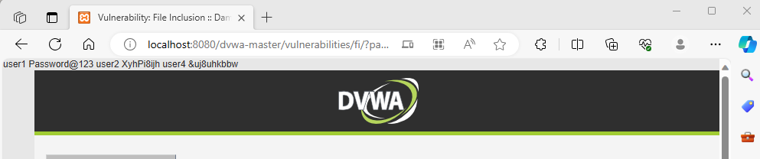

One More example
http://localhost:8080/dvwa-master/vulnerabilities/fi/?page=../../../../../etc/message.html
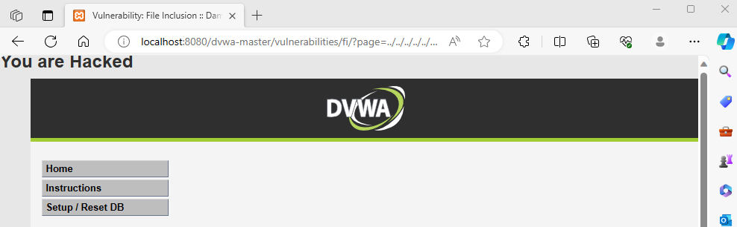

In a same way the user can call another site or execute a code which is present on their computer on to the website which is running on your server.
Refer to the below URL
http://localhost:8080/dvwa-master/vulnerabilities/fi/?page=http://localhost:8080/dvwa-master
The hacker has executed the home page on the File Inclusion Section just by changing the url pattern like how the directory was accessed.
PS : If you try to access www.google.com in the above form it will not work as google’s sites are already secured by such attacks well in advance & the DVWA Application is running on a HTTP and the google.com site is ruining in a HTTPS(Hyper Text Transfer Protocol Secure) mode. ( To run a site on HTTPS, one needs a SSL Certificate of the Site’s Name )
